Overall Evaluation
This is more than a “simple CRUD app.”
It already reads like a production-ready platform.
The strongest parts are:
- Security-focused architecture
- Real-world usability
- Clear separation of roles
- Real-time capabilities
- Analytics/reporting
- Fraud prevention logic
The project can easily stand out if you execute the UI cleanly and demonstrate a realistic voting flow.

What Makes It Hackathon-Competitive

1. Real-World Relevance
Many schools and clubs still:
- vote manually,
- use Google Forms,
- or rely on poorly secured systems.
Your solution addresses:
- transparency,
- accessibility,
- speed,
- and trust.
That gives your project practical value immediately.

Strongest Features

Secure Authentication
The inclusion of:
- JWT
- bcrypt
- OTP/email verification
- role-based access
already shows mature backend thinking.
You’re not just “making pages”; you’re building a secure system.

Fraud Prevention
This is one of the biggest differentiators.
Most student hackathon projects stop at:
- login,
- submit vote,
- display results.
You added:
- duplicate detection,
- IP restrictions,
- suspicious activity locks,
- audit logs,
- session tracking.
That moves the project toward enterprise-level thinking.

Real-Time Dashboard
Using Socket.IO for live vote updates is an excellent choice.
Judges love seeing:
- live charts moving,
- rankings updating,
- countdown timers,
- active voter counts.
It makes the demo feel alive.

Areas You Should Improve

1. Simplify the First Version
Right now the feature list is huge.
For a hackathon, focus on:
- stability,
- polish,
- working demo.
Do NOT try to build:
- blockchain,
- fingerprint auth,
- AI fraud detection,
- face recognition
unless you already have experience with them.
A polished core system beats a half-working “advanced” system.

Recommended MVP (Minimum Viable Product)
Focus on these:

Core Features
✅ Authentication
✅ Admin creates election
✅ Candidate management
✅ Voting system
✅ One vote per user
✅ Live results dashboard
✅ Responsive UI
✅ Election timer
✅ Charts/statistics

Optional If Time Allows
- Email notifications
- PDF export
- Audit logs
- QR verification

Skip Unless Extra Time Exists
- Blockchain
- AI fraud detection
- Biometrics

Best Tech Stack Choice
Your stack is good already.

Recommended Final Stack

Frontend
- HTML/CSS/JavaScript OR React
- Tailwind CSS (recommended)
- Chart.js

Backend
- Node.js
- Express.js

Database
- MongoDB
MongoDB fits hackathons better because:
- faster setup,
- flexible schema,
- easier iteration.

Authentication
- JWT
- bcrypt

Real-Time
- Socket.IO

UI/UX Suggestions
This part can massively increase judge scores.

Your UI Should Feel:
- modern,
- minimal,
- trustworthy,
- fast.
Think:
- dark blue + white theme,
- subtle gradients,
- clean cards,
- professional typography.

Recommended Screens

Landing Page
Should include:
- Hero section
- “Secure Digital Elections”
- Features cards
- Call-to-action buttons
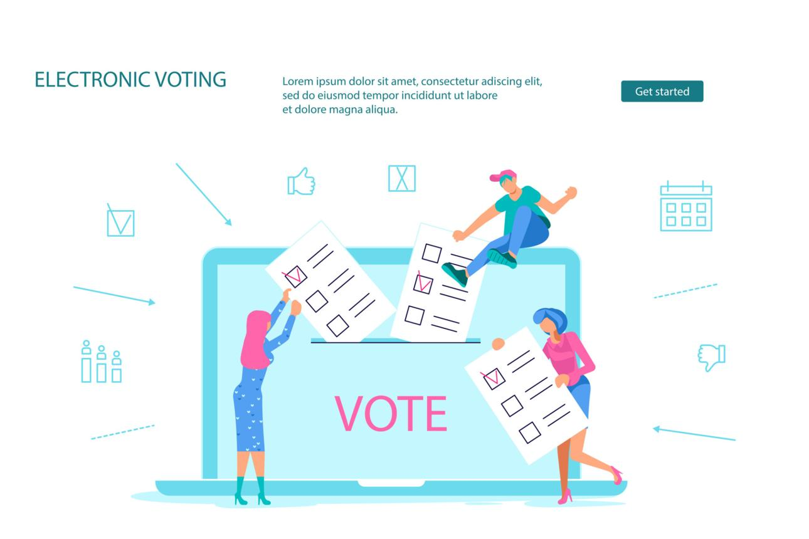
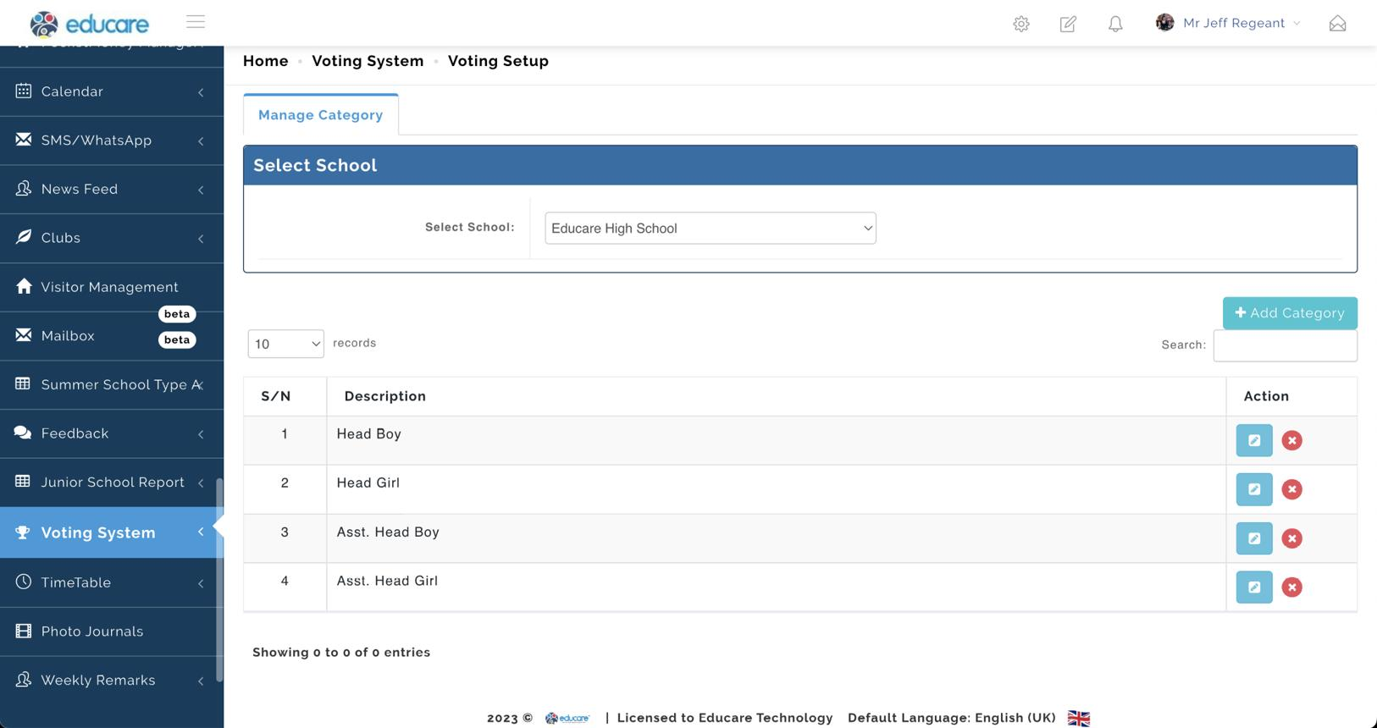
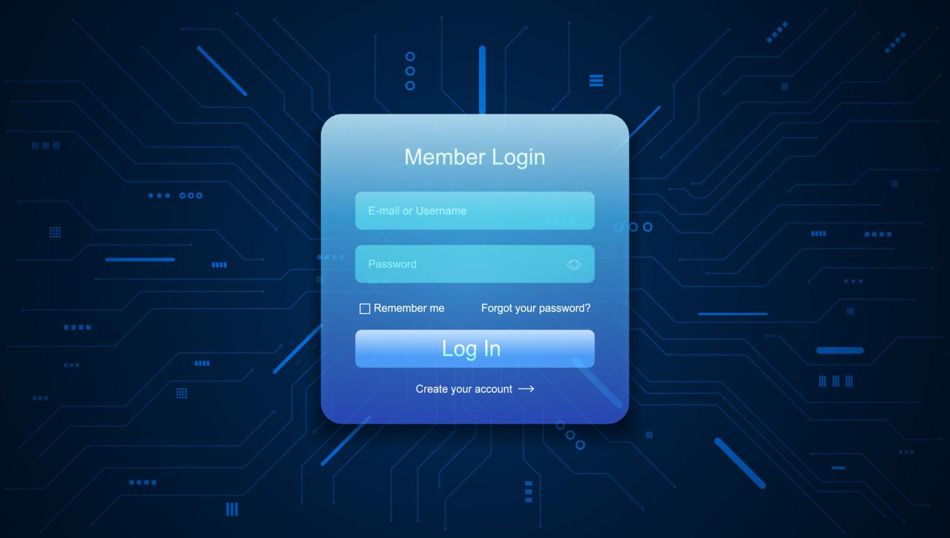
7

Student Voting Interface
Needs:
- candidate cards,
- photos,
- manifesto preview,
- vote button,
- countdown timer.
Very important:
Make voting feel simple and safe.
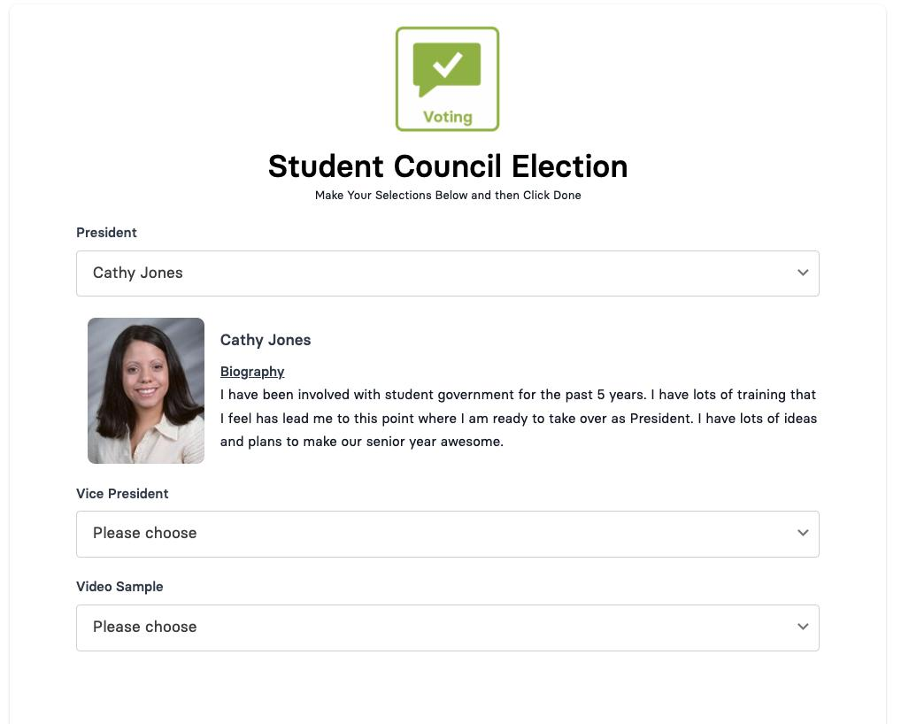
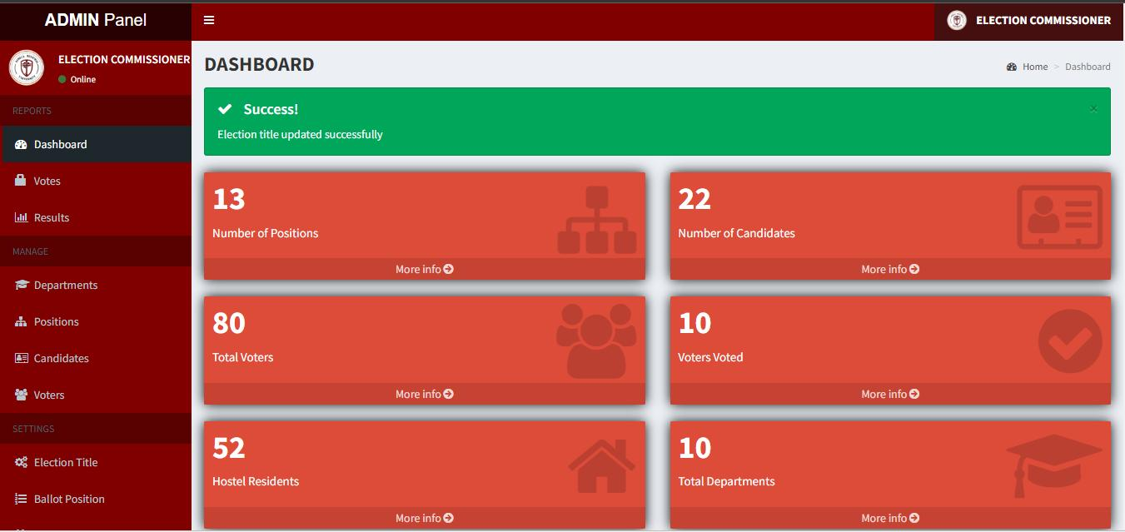
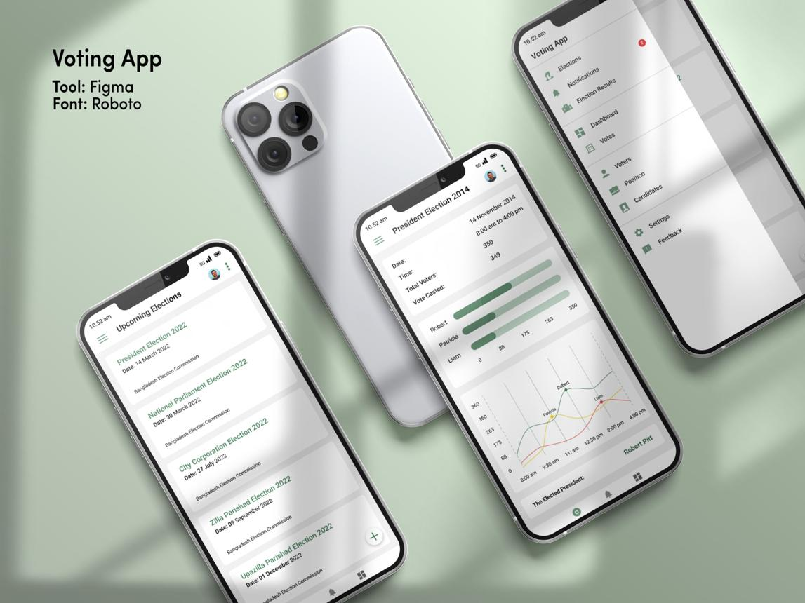
6

Admin Dashboard
This is where judges get impressed.
Should include:
- election analytics,
- active voters,
- vote charts,
- election controls,
- candidate management.
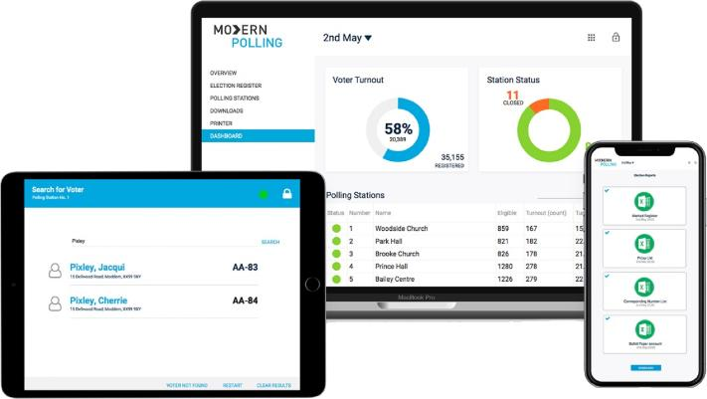
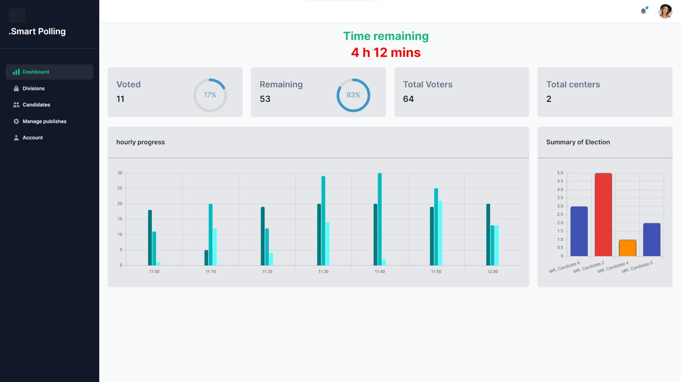
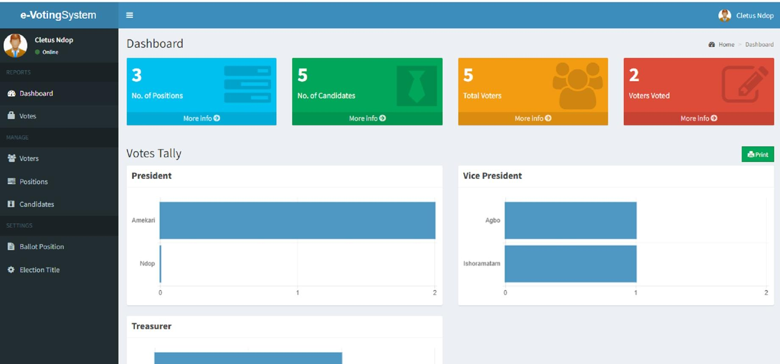
8

Secret Weapon for Demo Day

Tell a Story
Do not just click buttons randomly.
Demo flow:
- Admin creates election
- Candidates added
- Students log in
- Live voting begins
- Dashboard updates instantly
- Fraud prevention blocks duplicate vote
- Winner announced automatically
That narrative makes judges remember your project.

What Judges Usually Care About

They Score:
- originality,
- execution,
- polish,
- usability,
- technical difficulty,
- presentation quality.
Your project already scores high on technical depth.
Now focus on:
- UI polish,
- reliability,
- clean demo flow.

Final Verdict
This has strong hackathon potential.
If executed properly, it can look like a real startup product rather than a student assignment.
The biggest opportunity is combining:
- professional UI,
- real-time systems,
- security features,
- and a smooth presentation.
That combination is what usually separates finalists from average submissions.

